Class VI
Annual Exam Question Bank

Chapter 13: Fun with Magnets

Q1. Multiple Choice Questions:

1. When a bar magnet is brought near iron dust, most of the dust sticks
a. Near the middle
b. Equally everywhere
c. Near two ends
d. At the middle and ends

2. A piece of iron should be placed across the poles of horse shoe magnet
a. To conserve its magnetic property
b. To increase its magnetic property
c. To demagnetise it
d. To decrease its magnetic property.

3. ______ is a type of magnet which is used in cranes to lift heavy containers from dump yard.
a. Bar magnet
b. Cylindrical magnet
c. Electromagnet
d. Horseshoe magnet

Q2. Answer the following:

1. What is magnetic compass? Write any two uses of magnet.
2. Explain Demagnetisation with suitable examples.
3. It is advised to keep the magnets away from electronic devices.
4. The earth behaves like a giant magnet. Justify.

Q3. True or False

1. A cylindrical magnet has only one pole.
2. Bar magnets always point towards the North−South direction.
3. A bar magnet has no markings to indicate its poles.
4. In olden days, sailors used to find direction by suspending a piece of horse-shoe magnet.

Q4. HOTS:

1. Describe an activity to show that magnetic force is maximum at the poles of a bar magnet.
2. Discuss if magnet is rubbed haphazardly instead of rubbing in one direction?
3. What is a natural magnet? Identify whether a particular substance is magnetic or non-magnetic.

Chapter 14: Water

MCQS
- The wise and judicious use of water is known as:
- Water conservation
- Water cycle
- Wells are fed by
- Pond water
- Lake water
- Rain water
- Ground water
- “Catch water were it falls” is the basic idea behind.
- Recycling of water
- Making dams to store water
- Rain water harvesting
- Condensation of water vapour
SHORT ANSWER QUESTIONS
Question 1. How much water does a man use daily? Give a rough idea
Question 2. Why is water important for us?
Question 3. What do you mean by potable water?
Question 4. What is the ultimate source of water?
Question 5. What is the importance of water cycle?
Question 6. What are the consequences of large and prolonged rain?
Question 7. What would happen if it does not rain in a region for a year or more?
Question 8. Define water cycle
Question 9. Define transpiration
Question 10. Make a well labelled diagram of water cycle.
LONG ANSWER QUESTIONS
Question 1What is rain water harvesting?
Question 2 How can we conserve rainwater?
Question 3 How plants are playing an important role in water cycle?
Question 4 What are the major causes of water pollution?
Question 5 Suggest some preventive measures to minimise water pollution.

Chapter 15: AIR AROUND US
- Which gas in the atmosphere is essential for respiration?
- Nitrogen
- Oxygen.
- Hydrogen
- Carbon di oxide
- What is the composition of nitrogen in air?
- 21%
- 1%
- 78%
- 2%
- The ______________ makes windmill rotates.
- Water
- Wind
- Soil
- Machine
- Which gas is given to the patients having breathing problems?
- Oxygen
- Nitrogen
- Carbon-di-oxide
- Hydrogen
- Name the gas in the air, which is used by the plants while making food.
- Oxygen
- Carbon-di-oxide
- Hydrogen
- Helium
- Why is atmosphere necessary for life on earth?
- Explain why, earthworms come out of the soil only during heavy rains.
- How will you show that air is present in lump of soil?
- Explain why, tall chimneys are installed in factories?
- Why plants need nitrogen?
- Explain with the flow diagram oxygen-carbondioxide balance in atmosphere.
- Explain what does this experiment proves.
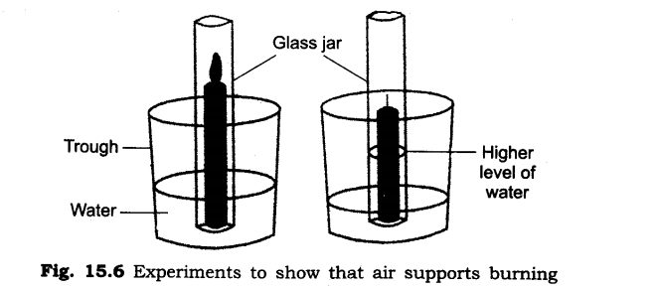
- Explain the cycle in your own words.
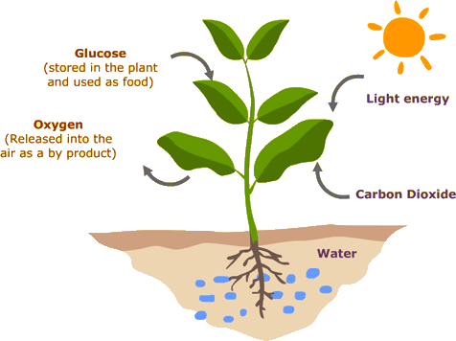
- Why do you think that traffic police man is wearing mask while he is on duty?
- How will you show that air is dissolved in water?

Chapter 16: Garbage In, Garbage Out

Q1. Multiple Choice Questions:

1. If leaves are fallen from the tree, select the correct way of disposal
a. Burning
b. Making compost by boiling and drying them
c. Making compost by vermicomposting
d. Any of these methods

2. Which of the following can be recycled?
a. Waste paper
b. Leather shoes
c. Animal waste
d. Kitchen waste

3. Materials that can be recycled are collected in
a. Red bins
b. Blue bins
c. Yellow bins
d. White bins

Q2. True or False

1. All animals breathe in oxygen through lungs.
2. Plants not absorb nitrogen directly from the atmosphere.
3. The amount of water vapours present in the air is called as humidity.

Q3. Answer the following:
1. Distinguish between Respiration and Breathing.
2. Do plants require nitrogen? Why?
3. List any four uses of air.

Q4. HOTS:

1. Most plants have stomata on the undersides of leaves. However, water lily leaves have stomata on the upper surface. Why?
2. How does the atmosphere help to maintain the right temperature on the earth?
3. Is it good to sleep under a tree during the day or at night? Give reasons.
4. An aquarium owner, on a rather cold day, put a heater in his aquarium, which made the water warm, but not hot. He thought the fish would like that. However, all his fish died. What could be the reason for this?

